**CDAC Feb 2015**

**LAB 8**

Q4. Priority Resolver

Name: Bhrigu Bhargava

PRN: 150240133004

**Priority Resolver**

# Design Approach:

In the design approach, initially device A has highest priority 4 & on the other hand device D has lowest priority 1.We have implemented arbiter by implementing least recently used algorithm. The special attribute of this algorithm is that the round robin algorithm also forms subset for it in some cases.

To minimize the code using behaviour style, we have used case statement for 16 cases of request considering we have 4 devices. Following the assignment, we have then assigned priority of devices, as per their usage and then reassigned priorities to others below it. We have used separate always block for deciding priority.

**Synthesis:**

1. RTL Schematic

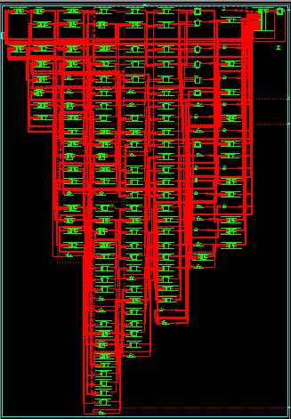

1. Block Diagram

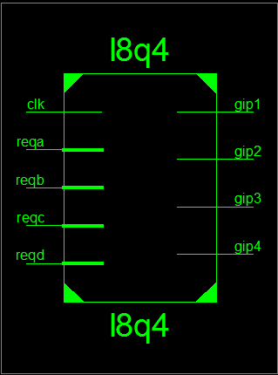

1. Tech Schematic

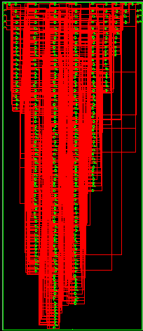

1. Simulation Waveform Result

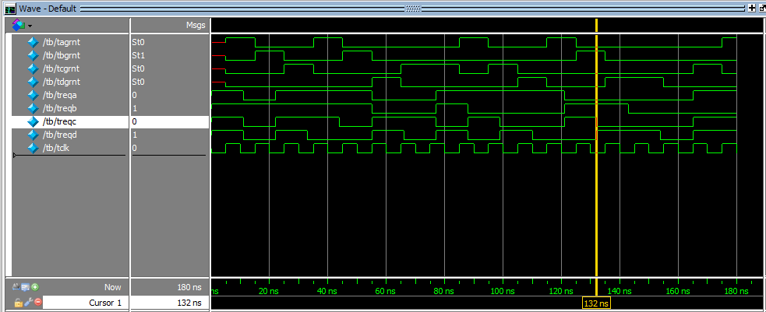

**Error:**

None